Assignment #13 Forecasting using Regression by Joshua Troup

Q1: Plot the pre-event AIR time series (Before Sep 2001).

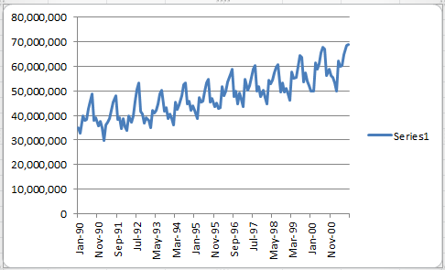

Q2: What time series components (Level, Trend, Seasonality, Noise) appear from

the plot?

**Trend and Seasonality**

Q3: Do you think Linear Regression Model with trend would be adequate for

forecasting the AIR time series?

**Yes, they are popular forecasting techniques. They use suitable predictors (input variables) to capture trends or patterns and seasonality.**

Q4: Specify a linear regression model for the AIR series that would produce a

seasonally adjusted series with multiplicative seasonality. What is the output

variable? What are the predictors?

**Multiple Linear Regression. Output variable = Natural log of the Y. Predictors = Time index (12 months) transforms into dummy variables 12-1 = 11 dummy variables which are months.**

Q5: What can we learn from the statistical insignificance of the coefficients for October and September?

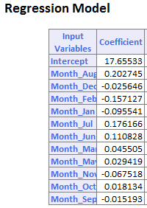

**September and October coefficients are very small. The coefficient is the expected difference in response per unit difference.**

Q6: What is the residual for this month of Jan 1990, using the regression model? Report the residual in terms of air revenue passenger miles.

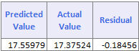

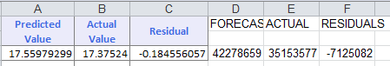

Q7: What does the ACF plot tell us about the regression model’s forecasts?

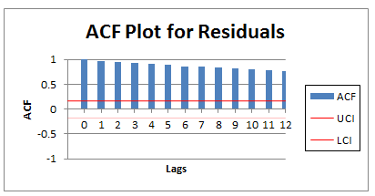

**The lags are positively correlated. If one month is over predicted, it is likely the next month will be as well. The lags slowly decrease with 0 have 1 and 12 having .7680.**

Step 4: Fit linear regression models to Air, Rail and Auto with additive seasonality and an appropriate trend.

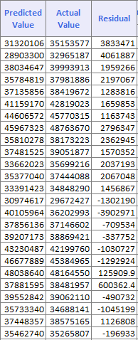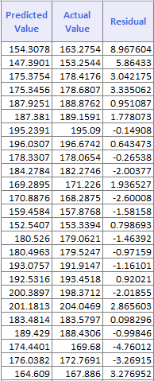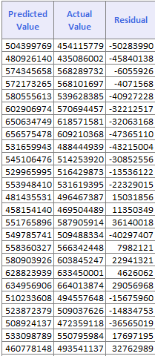

AIR AUTO RAIL

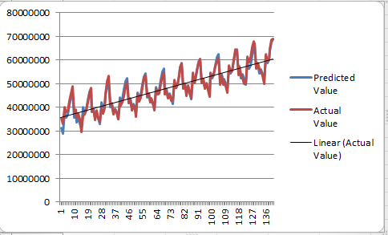

AIR

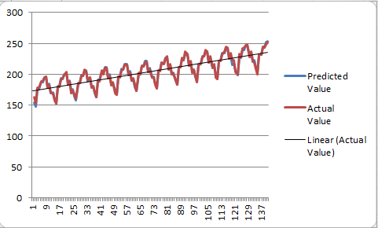

AUTO

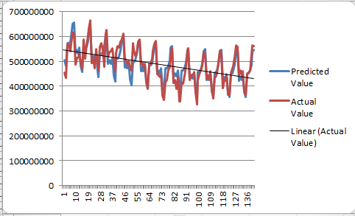

RAIL

Q8: What can be said about the effect of the September 11 terrorist attack on the three modes of transportation? Discuss the magnitude of the effect, its time span, and any other relevant aspects.

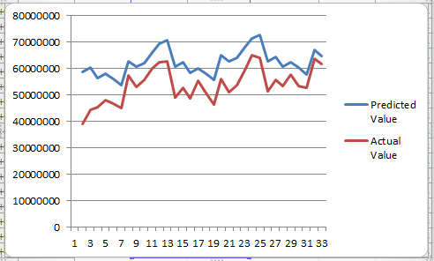

**POST AIR**

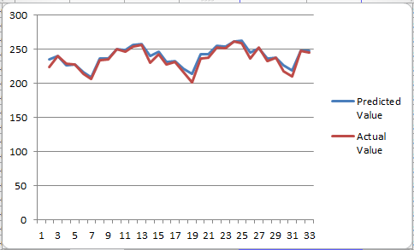

**POST AUTO**

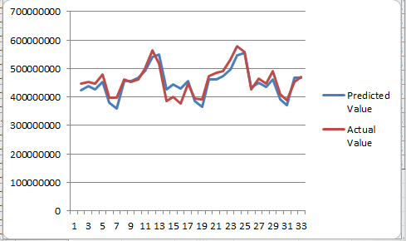

**POST RAIL**

**Prior to 9/11, Air travel was sky rocketing at a steady rate (70,000,000 Aug 01 and rising). The actual value after the terrorist attack is much lower than the predicted value. (Sept 01 shows less than 40,000,000). Post air plot shows some noise or randomness however the values are slightly increasing over time from the post terrorists early months.**

**Auto was on a steady increase pre 9/11. Post shows some noise but staying relative close to 250 with some variations (seasonality).**

**Rail was on a decline prior to 9/11 as many people were resorting to air travel. Post shows seasonality trend with the miles being adequate to the pre terrorist values at a steady plateau.**